# The Great Depression

by John Smith and Jane Doe

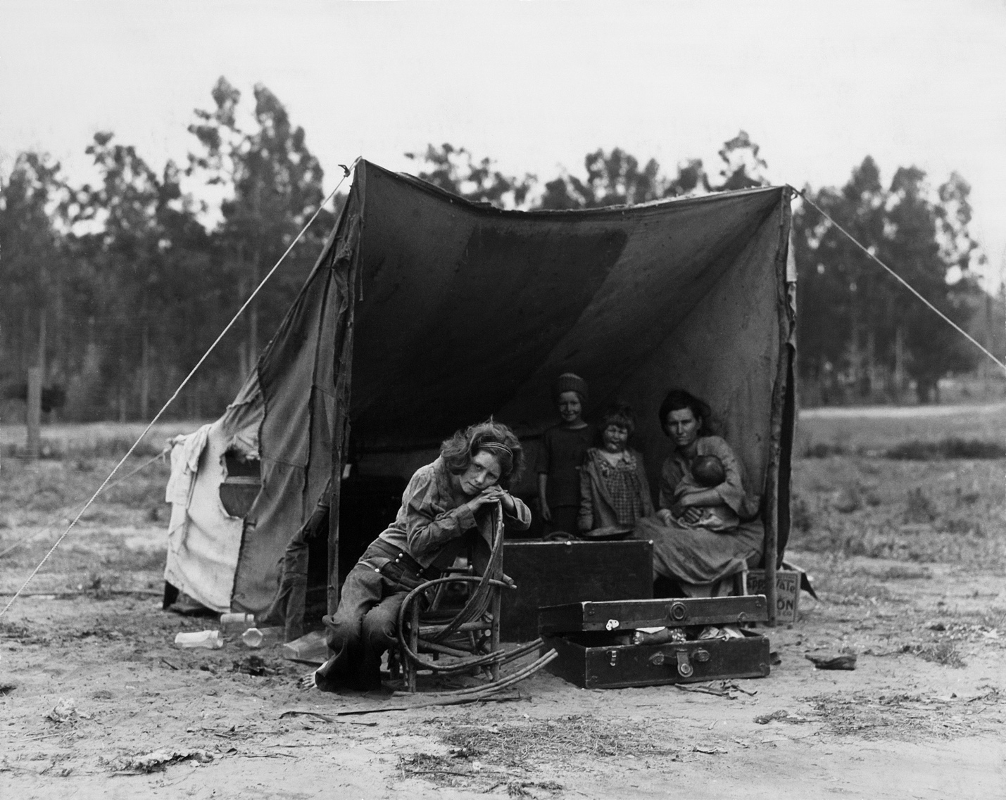

© 2020 CAST, Inc

NIMAS Social Studies Textbook Exemplar, 2nd Edition

ISBN: 9781122334455

**Table of Contents**

**The Great Depression**

Overview

Troubled Times

FARM LIFE AND THE DUST BOWL

THE DUST BOWL MIGRATION

FARM TENANTS

ELECTRIC FARMS

Dorothea Lange, Photographer of the Great Depression

KEEPING SPIRITS UP

Review

Review Questions

Key Words

**Note:**  Although not included in this document, the page numbers in a NIMAS XML file should match those in the print source.

# The Great Depression

## Overview

During the 1920s, the United States saw a time of great prosperity. However, that would all change with the stock market crash of 1929. The country and the world would be plunged into an economic and social depression.

Companies were going bankrupt, banks were shutting down, and unemployment was skyrocketing.

One president would ignore the problem, another would radically alter the powers of government to help the nation. People were starving both in the cities and on the farms of America.

Throughout the 1930s and into the 1940s, the people of the United States faced some of their toughest years. Only the Second World War would put an end to the Great Depression.

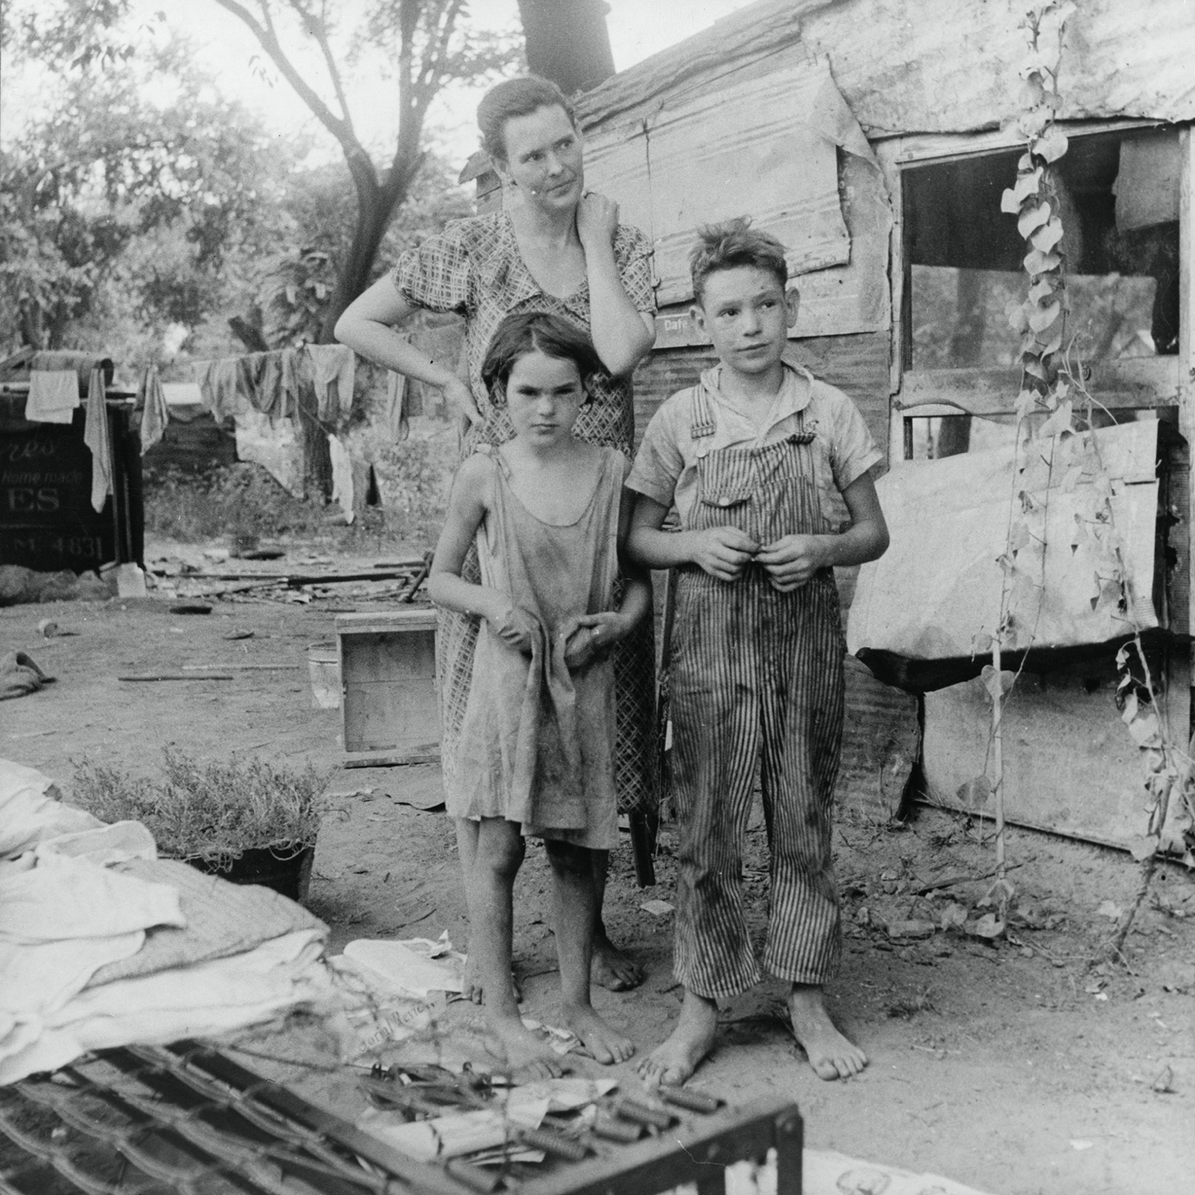

The Great Depression caused immediate hardship on everyday life. Hundreds of thousands of people lost their homes, their jobs, and their dignity. Families, like the one shown above, were forced to live in make-shift camps that were overcrowded and unsanitary.

**KEY POINTS**

* The causes of the Great Depression, culminating in the stock market crash of 1929
* Herbert Hoover’s presidency and ineffective actions toward the economic crisis
* The New Deal and the challenges of FDR’s presidency
* Life during the Great Depression in cities, on farms, and in the entertainment industry

## Troubled Times

Cities were hard hit by the Great Depression. By March of 1930, more than 3.2 million people were unemployed. Since most people lost their homes, homelessness ran rampant. People were living literally “in the streets.” Whole families were living in boxes, under bridges and overpasses, and in alleys. The street corners of New York City were packed with people selling anything and everything to try and make money. “Desperate times began to put into question the old American notion that if a man worked hard enough, he could always take care of himself and his family. The effect of the Depression on poor children was particularly severe.... Most elderly Americans did not have personal savings or retirement pensions to support them in normal times, let alone during a national economic crisis.... Even skilled workers, business owners, successful farmers, and professionals of all kinds found themselves in severe economic difficulty as one out of four in the labor force lost their jobs.” (CRF, www.crf-usa.org.)

**Depression Era Unemployment**

|  |  |  |  |
| --- | --- | --- | --- |
|  | **Year** | **U.S. Population** | **Unemployment Percentage** |
|  | 1929 | 88,010,000 | 3.14 |
|  | 1930 | 89,550,000 | 8.67 |
|  | 1931 | 90,710,000 | 15.82 |
|  | 1932 | 91,810,000 | 23.53 |
|  | 1933 | 92,950,000 | 24.75 |
|  | 1934 | 94,190,000 | 21.60 |
|  | 1935 | 95,460,000 | 19.97 |
|  | 1936 | 96,700,000 | 16.80 |
|  | 1937 | 97,870,000 | 14.18 |
|  | 1938 | 99,120,000 | 18.91 |
|  | 1939 | 100,360,000 | 17.05 |
|  | 1940 | 101,560,000 | 14.45 |
|  | 1941 | 102,700,000 | 9.66 |

*Source: U.S. Bureau of the Census, Historical Statistics of the United States, Colonial Times to 1957 (Washington, D.C., 1960), p. 70.*

People were living in the streets and they were starving. They were becoming angry and desperate. Food riots broke out across the nation. In Minneapolis, people smashed the windows of a store and stole fruit, canned goods, bacon, and ham. When one of the shop owners tried to stop them at gunpoint, one of the looters broke his arm. It took 100 police officers to bring the riot under control. Seven people were arrested.

Some cities tried to control the problem by distributing food to people who waited in **bread lines** to get a meal. In New York City, there were 82 different bread lines located in different stations around the city. In 1931, each of these lines averaged 85,000 meals a day. A typical meal consisted of bread, soup, and stew. People would stand in these lines for days waiting for one meal. Many people fainted while standing in line from exhaustion, fatigue, and hunger.

New York also tried to provide citywide relief to its homeless, jobless masses. But by April of 1932, more than 750,000 New Yorkers were dependent on city relief with a waiting list of 160,000 people. The people on relief began to outnumber the people working. The city could not support this relief much longer.

Franklin Delano Roosevelt was elected in 1933 on his “new deal” platform of recovery and reform. His inauguration speech contained the now-famous quote:

“Let me assert my firm belief that the only thing we have to fear is fear itself—needless, unreasoning, unjustified terror which paralyzes needed efforts to convert retreat into advance.”

**FDR's Inaugural Address, 1933:**   
  
President Hoover, Mr. Chief Justice, my friends: This is a day of national consecration, and I am certain that my fellow Americans expect that on my induction into the Presidency I will address them with a candor and a decision which the present situation of our nation impels. This is pre-eminently the time to speak the truth, the whole truth, frankly and boldly. Nor need we shrink from honestly facing conditions in our country today. This great nation will endure as it has endured, will revive and will prosper. So first of all let me assert my firm belief that the only thing we have to fear is fear itself—nameless, unreasoning, unjustified terror which paralyzes needed efforts to convert retreat into advance. In every dark hour of our national life a leadership of frankness and vigor has met with that understanding and support of the people themselves which is essential to victory. I am convinced that you will again give that support to leadership in these critical days.

In such a spirit on my part and on yours we face our common difficulties. They concern, thank God, only material things. Values have shrunken to fantastic levels: taxes have risen, our ability to pay has fallen, government of all kinds is faced by serious curtailment of income, the means of exchange are frozen in the currents of trade, the withered leaves of industrial enterprise lie on every side, farmers find no markets for their produce, the savings of many years in thousands of families are gone.

More important, a host of unemployed citizens face the grim problem of existence, and an equally great number toil with little return. Only a foolish optimist can deny the dark realities of the moment.

Yet our distress comes from no failure of substance. We are stricken by no plague of locusts. Compared with the perils which our forefathers conquered because they believed and were not afraid, we have still much to be thankful for. Nature still offers her bounty and human efforts have multiplied it. Plenty is at our doorstep, but a generous use of it languishes in the very sight of the supply. Primarily, this is because the rulers of the exchange of mankind's goods have failed through their own stubbornness and their own incompetence, have admitted their failures and abdicated. Practices of the unscrupulous money changers stand indicted in the court of public opinion, rejected by the hearts and minds of men.

True, they have tried, but their efforts have been cast in the pattern of an outworn tradition. Faced by failure of credit, they have proposed only the lending of more money. Stripped of the lure of profit by which to induce our people to follow their false leadership, they have resorted to exhortations, pleading tearfully for restored conditions. They know only the rules of a generation of self-seekers. They have no vision, and when there is no vision the people perish.

The money changers have fled their high seats in the temple of our civilization. We may now restore that temple to the ancient truths. The measure of the restoration lies in the extent to which we apply social values more noble than mere monetary profit.

Happiness lies not in the mere possession of money, it lies in the joy of achievement, in the thrill of creative effort. The joy and moral stimulation of work no longer must be forgotten in the mad chase of evanescent profits. These dark days will be worth all they cost us if they teach us that our true destiny is not to be ministered unto but to minister to ourselves and to our fellow-men.

Recognition of the falsity of material wealth as the standard of success goes hand in hand with the abandonment of the false belief that public office and high political position are to be values only by the standards of pride of place and personal profit, and there must be an end to a conduct in banking and in business which too often has given to a sacred trust the likeness of callous and selfish wrongdoing. Small wonder that confidence languishes, for it thrives only on honesty, on honor, on the sacredness of obligations, on faithful protection, on unselfish performance. Without them it cannot live.

Restoration calls, however, not for changes in ethics alone. This nation asks for action, and action now.

Our greatest primary task is to put people to work. This is no unsolvable problem if we face it wisely and courageously. It can be accompanied in part by direct recruiting by the government itself, treating the task as we would treat the emergency of a war, but at the same time, through this employment, accomplishing greatly needed projects to stimulate and reorganize the use of our national resources.

Hand in hand with this, we must frankly recognize the over-balance of population in our industrial centers and, by engaging on a national scale in a redistribution, endeavor to provide a better use of the land for those best fitted for the land. The task can be helped by definite efforts to raise the values of agricultural products and with this the power to purchase the output of our cities. It can be helped by preventing realistically the tragedy of the growing loss, through foreclosure, of our small homes and our farms. It can be helped by insistence that the Federal, State, and local governments act forthwith on the demand that their cost be drastically reduced. It can be helped by the unifying of relief activities which today are often scattered, uneconomical, and unequal. It can be helped by national planning for and supervision of all forms of transportation and of communications and other utilities which have a definitely public character. There are many ways in which it can be helped, but it can never be helped merely by talking about it. We must act, and act quickly.

Finally, in our progress toward a resumption of work we require two safeguards against a return of the evils of the old order: there must be a strict supervision of all banking and credits and investments; there must be an end to speculation with other people's money, and there must be provision for an adequate but sound currency.

These are the lines of attack. I shall presently urge upon a new Congress in special session detailed measures for their fulfillment, and I shall seek the immediate assistance of the several States.

Through this program of action we address ourselves to putting our own national house in order and making income balance outgo. Our international trade relations, though vastly important, are, to point in time and necessity, secondary to the establishment of a sound national economy. I favor as a practical policy the putting of first things first. I shall spare no effort to restore world trade by international economic readjustment, but the emergency at home cannot wait on that accomplishment.

The basic thought that guides these specific means of national recovery is not narrowly nationalistic. It is the insistence, as a first consideration, upon the interdependence of the various elements in and parts of the United States ... a recognition of the old and permanently important manifestation of the American spirit of the pioneer. It is the way to recovery. It is the immediate way. It is the strongest assurance that the recovery will endure.

In the field of world policy I would dedicate this nation to the policy of the good neighbor—the neighbor who resolutely respects himself and, because he does so, respects the rights of others—the neighbor who respects his obligations and respects the sanctity of his agreements in and with a world of neighbors.

If I read the temper of our people correctly, we now realize, as we have never realized before, our interdependence on each other: that we cannot merely take, but we must give as well, that if we are to go forward we must move as a trained and loyal army willing to sacrifice for the good of a common discipline, because without such discipline, no progress is made, no leadership becomes effective. We are, I know, ready and willing to submit our lives and property to such discipline because it makes possible a leadership which aims at a larger good. This I propose to offer, pledging that the larger purposes will bind upon us all as a sacred obligation with a unity of duty hitherto evoked only in time of armed strife.

With this pledge taken, I assume unhesitatingly the leadership of this great army of our people, dedicated to a disciplined attack upon our common problems.

Action in this image and to this end is feasible under the form of government which we have inherited from our ancestors. Our Constitution is so simple and practical that it is possible always to meet extraordinary needs by changes in emphasis and arrangement without loss of essential form. That is why our constitutional system has proved itself the most superbly enduring political mechanism the modern world has produced. It has met every stress of vast expansion of territory, of foreign wars, of bitter internal strife, of world relations.

It is to be hoped that the normal balance of executive and legislative authority may be wholly adequate to meet the unprecedented task before us. But it may be that an unprecedented demand and need for undelayed action may call for temporary departure from that normal balance of public procedure.

I am prepared under my constitutional duty to recommend the measures that a stricken nation in the midst of a stricken world may require. But in the event that the Congress shall fail to take one of these courses, and in the event that the national emergency is still critical, I shall not evade the clear course of duty that will then confront me. I shall ask the Congress for the one remaining instrument to meet the crisis—broad executive power to wage a war against the emergency as great as the power that would be given to me if we were in fact invaded by a foreign foe.

For the trust reposed in me I will return the courage and the devotion that befit the time. I can do no less.

We face the arduous days that lie before us in the warm courage of national unity, with the clear consciousness of seeking old and precious moral values, with the clean satisfaction that comes from the stern performance of duty by old and young alike. We aim at the assurance of a rounded and permanent national life.

We do not distrust the future of essential democracy. The people of the United States have not failed. In their need they have registered a mandate that they want direct, vigorous action. They have asked for discipline and direction under leadership. They have made me the present instrument of their wishes. In the spirit of the gift I take it.

In this dedication of a nation we humbly ask the blessing of God. May He protect each and every one of us. May He guide me in the days to come.  
  
FDR

Despite the election of FDR and all his New Deal programs, unemployment in cities remained high and began to take its toll on society. Unemployed men felt a loss of status because they could not provide for their families. They became easily agitated and irritable which resulted in many fights and quarrels in public places. Women who had jobs suddenly came under immense social pressure to give their jobs to unemployed men. Women were told that men “deserved” the job more than they did. Almost all married women lost their jobs, even if they were the only person in the family working. Women were relegated to servant positions that society saw as more suited to women than men. These jobs usually paid much less than the jobs they had to give up.

Children were also put to work. Boys and girls by the hundreds dropped out of school and either began working low-paying jobs or staying home to look after younger siblings while both their parents worked. Teenagers dropped out of school and frequently left their families. Most could not find jobs and their families could not support them. Many city youth ran away from the city and “rode the rails,” or roamed the country by railroad. These youth would sneak onto trains, beg for food, and live in **squatter camps** along the railroad routes.

****Cities were full of unemployed, homeless, starving people who could not find work despite FDR’s New Deal programs. This chaos led to food riots and strain on city budgets. Society pressured women out of jobs, children into jobs, and teenagers to ride the rails.

### FARM LIFE AND THE DUST BOWL

The Depression attacked farms as quickly and as destructively as it did the cities. The problems facing farmers were numerous and complex and could not be fixed with a single solution.

#### THE DUST BOWL MIGRATION

During the 1920s, farms were prospering and there was such an abundance of rainfall that farmers all across the western United States had become careless in their farming techniques and soil preparation. Farmers over-grazed livestock and over-plowed fields to make more money. This damaged the land and destroyed the regenerative properties of the soil. During the 1930s, there was a large drought in the West, causing crops to shrivel, cattle to die, and the topsoil to blow away. This turned the West into one large **dust bowl**.

The states in the dust bowl region were Kansas, Oklahoma, Texas, Colorado, and New Mexico. This region was called the dust bowl because of the large numbers of **dust storms** that occurred there. However, other states, such as Arkansas and the Dakotas were also plagued by dust storms.

What is a dust storm? Dust storms are storms that last for several days, driven by high winds. The winds blow dust, creating huge dark, yellowish clouds that, at times, can block out the light of the sun. Sometimes, these dust clouds can get up to 8,000 feet high and be accompanied by thunder and lightning. Two massive and highly destructive dust storms occurred in the 1930s. The first was in May of 1934.

A dust storm lasting three days blew across the West and Southwest, pulling up over 350 million tons of soil and dropping it as far east as New York City, New York and Boston, Massachusetts. It was reported that these cities had to turn on streetlamps in the daytime just to be able to see through the blowing dust. The second storm occurred in March of 1935 in the Dakotas and Nebraska. It destroyed the entire wheat crop for both states and swept away as much dirt as workers dug up when they constructed the Panama Canal.

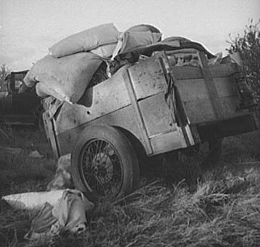

People living in the dust bowl states packed up everything they owned and migrated west. They pulled wagons filled with their personal goods, like the one shown above, behind their cars or trucks.

Not only were these dust storms economically damaging, they were a danger to the people living in these states. People caught outside in dust storms could suffocate and die from dust inhalation. Because of the havoc these storms wreaked on the land and the people living on it, people were forced to **migrate** to find work or a new place to farm. Many packed up everything they owned into trucks, cars, and wagons and began to travel further west to California and other Pacific states. Over 2.5 million people fled to California during the Great Depression. The migrants began to gather nicknames based on where they were migrating from such as “Oakies” if they were from Oklahoma and “Arkies” if they were from Arkansas. These people pushed west into Texas, Kansas, Nebraska, and the Dakotas, and, finding no relief in these dust bowl-burdened states, pushed on to California.

Unfortunately, California could not support the huge influx of people that began to pour into the state. California was not a huge farming state, and the small farm towns it did have quickly became overcrowded and overrun with migrants looking for work and land to farm. By 1939, the problem had become so bad that the California state government passed a law forbidding entry of any new people into the state. The Supreme Court overturned this law as unconstitutional, and people continued to flood the state.

The federal government in the 1930s tried to alleviate the crisis by taking measures to salvage the land that had been destroyed by the dust storms and poor farming techniques. In 1933, the government created the Soil Erosion Service. This was a commission that taught terracing and contour farming techniques to farmers to help them preserve the soil. In 1936, the government passed the Soil Conservation Act, which tried to reduce farm surpluses and promote soil conservation. The government also planted over 200 million trees in the most ravaged parts of the dust bowl from the Dakotas to Texas. These trees took to the soil and began to grow, providing “shelter belts” along the West and conserving water to help hold down the topsoil. The dust bowl was slowly beginning to replenish itself.

#### FARM TENANTS

Aside from the growing dust storms and bad soil, there was another class of farmers affected by the Great Depression. These were tenant farmers or **sharecroppers**. After the Civil War, sharecroppers replaced slaves on many farms. Some sharecroppers were former slaves, while others were poor white farmers. Sharecroppers, or tenant farmers, did not own their land. They were not paid any wages. Someone else owned the land they farmed, and the sharecroppers rented it. They paid these landowners with a “share” of the crops and other goods produced on that farm. Most of these farmers could only obtain the seed, food, and clothes they needed each year by pledging their harvest in advance.

When the Great Depression hit these farms, not to mention the dust storms, most sharecroppers had already pledged their crops and other goods in advance. The dying crops and bad soil could not produce enough for the farmers to live off of, so they were unable to pay their share to the landowners. As a result, they were forced to leave the land burdened with huge debts they had no hope of paying.

The federal government, again, tried to help, by passing the Federal Emergency Relief Act to help tenant farmers. This act gave money, seeds, and equipment to these farmers and tried to relocate them to better land. It helped some, but not all sharecroppers, escape total poverty.

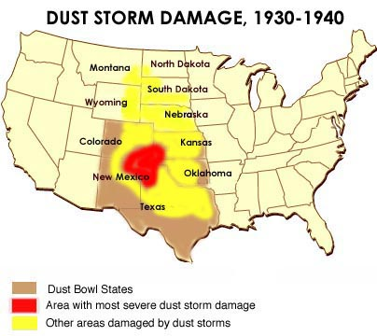

This map shows the states that were considered dust bowl states and the areas affected by dust storms. Notice that many states not considered dust bowl states were still damaged by dust storms. The whole middle of the United States was literally blowing away.

#### ELECTRIC FARMS

Another major problem that farmers faced during the Great Depression was lack of electricity. Before the depression hit, only one in ten farms had electricity. After the depression and the major dust storms, it became apparent that more farms needed electricity and quickly! So the federal government formed the Rural Electrification Administration to bring electricity to farms in the West. The REA had the power to loan money to farmers and small towns to help them build generators and install power lines. This action was one of the most revolutionary and successful actions during the Great Depression. By 1941, four out of five American farms now had electricity.

****Powerful dust storms in the 1930s created a dust bowl in the middle of the United States. Farmers and their families were forced to migrate in droves to California and other points West. Sharecroppers faced debt from lack of crops, and farms in the West needed electricity. The federal government set up programs to help, and were, for the most part, successful.

#### Dorothea Lange, Photographer of the Great Depression

Dorothea Langedecided to travel the world at age 20, taking pictures and selling her photographs. By the time she settled down in San Francisco, California in 1916, she had gathered a reputation as an innovative, talented documentary photographer.

During the Great Depression, she wanted to expand her talents and began by photographing the homeless men in the cities around the country. One of those photographs, White Angel Breadline, gained the attention of not only her colleagues, but also the federal government. The government hired her to work with the Resettlement Association of the 1930s to bring the conditions of the poor to the attention of the public. She traveled with and photographed hundreds of migrant workers. Her photographs directly contributed to the establishment of better housing camps for migrant workers in California.

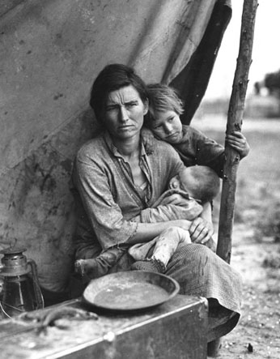

Dorothea Lange's most famous photograph is entitled *Migrant Mother* taken in Nipomo, California in 1936. Lange was famous for capturing the hardship, anguish, and the humanity of the Great Depression.

#### KEEPING SPIRITS UP

During the Great Depression, not only was the economy depressed, but also were the people. The morale of American society was down and out. The country and its people needed hope, and the entertainment industry tried hard to keep America’s spirits up.

Books, movies, and music were dedicated to bringing up American morale. Most of the books were reality-based books about the state of affairs such as *Let Us Now Praise Famous Men* by James Agee and Walker Evans, that told the story of tenant farmers, and *The Grapes of Wrath* by John Steinbeck, that fictionalized the story of a dust bowl family’s migration west. Both of these novels were extremely popular because they told the truth and gave a voice to the people of the nation who felt like no one was listening.

Movies took a different tack. Some studios projected the image of the ideal life or a hopeful future, such as many of the Shirley Temple movies of the 1930s. Others films were pure escapism, like The Wizard of Oz. People flocked to the movies either to be encouraged by the future or to forget the present.

Also during this time, comics were introduced with superhero characters such as Superman. These comics had characters with extraordinary powers that helped the poor, downtrodden, and innocent.

The music industry also worked hard to raise people’s spirits. Many parlor songs of the time were uplifting, with messages of hope for the future with titles such as “When the Shepherd Leads the Sheep Back Home” (1931) and “The Clouds Will Soon Roll By” (1932). Some songs took on a more humorous and whimsical tone to help refocus people’s attention away from the bad times, such as “Here It is Monday and I’ve Still Got A Dollar” (1932).

One of the most popular songs of the era was “Pennies from Heaven”:

A long time ago  
A million years B.C.  
The best things in life  
Were absolutely free  
But no one appreciated  
A sky that was always blue  
And no one congratulated  
A moon that was always new  
So it was planned that they would vanish now and then  
And you must pay before you get them back again  
That’s what storms were made for  
And you shouldn’t be afraid, for  
Every time it rains it rains  
Pennies from heaven  
Don’t you know each cloud contains  
Pennies from heaven  
You’ll find your fortune falling  
All over town  
Be sure that your umbrella is upside down  
Trade them for a package of sunshine and flowers  
If you want the things you love  
You must have showers  
So when you hear it thunder  
Don’t run under a tree  
There’ll be pennies from heaven for you and me

*Written by Johnny Burke and Arthur Johnston (www.lyrics007.com).*

Other types of entertainment slipped in to help society refocus. In 1930, the first pinball machine hit the scene, and in 1935, Parker Brothers distributed the first version of the board game Monopoly. People took to these distractions, and they helped to pass what was one of the hardest times in American history.

****The morale of the American people fell rapidly during the Great Depression. Books, movies, and music worked overtime to keep people hopeful and happy. These types of entertainment gave people hope and joy in a very tough time.*

## Review

### Review Questions

* How did the high unemployment rate effect society?
* What were three of the main problems facing farmers?
* What ways did the government try to help farmers? Were they successful? Why or why not?
* Why do you think the Supreme Court declared the 1939 California law forbidding state entry unconstitutional?
* Why do you think comic books with superheroes were so popular during the Great Depression?
* Write an essay that analyzes and assesses the overall effects of the Great Depression on cities, farms, and society. Discuss the major problems and how people coped, how the government acted, and how the entertainment industry tried to help.

### Key Words

**bread lines**

lines at food distribution centers where people often faced long waits to get a meal during the Great Depression

**dust bowl**

section of the Great Plains of the United States where a severe drought took place in the early 1930s

**dust storms**

strong storms that blew large amounts of dust from the bare, dry soil in the Dust Bowl across a number of U.S. states

**migrate**

to move from one region to another

**share cropper**

a farmer who provides a portion of each crop to the owner of the land as rent

**squatter**

a person who lives on land he or she does not own or rent

To learn more about the USA during the Depression era, read *The Great Depression: America 1929–1941* by Robert S. McElvaine, or *The Hungry Years: A Narrative History of the Great Depression in America* by T. H. Watkins.

Copyright, 2020 CAST, Inc.

This exemplar is provided so that publishers, conversion houses, developers, and others may enhance their understanding of NIMAS XML source files. The content was authored and is copyrighted by CAST, Inc., and it may not be reproduced, redistributed, sold, or transmitted without the express consent of CAST. CAST makes no representation that the enclosed NIMAS-conformant files are without error, nor that they include all of the elements listed in the NIMAS DTD. It is a work in progress and is shared to promote feedback and discussion. Please email feedback and comments to aem@cast.org.